Appendix G.1 — ET2/ET5/ET6 Code
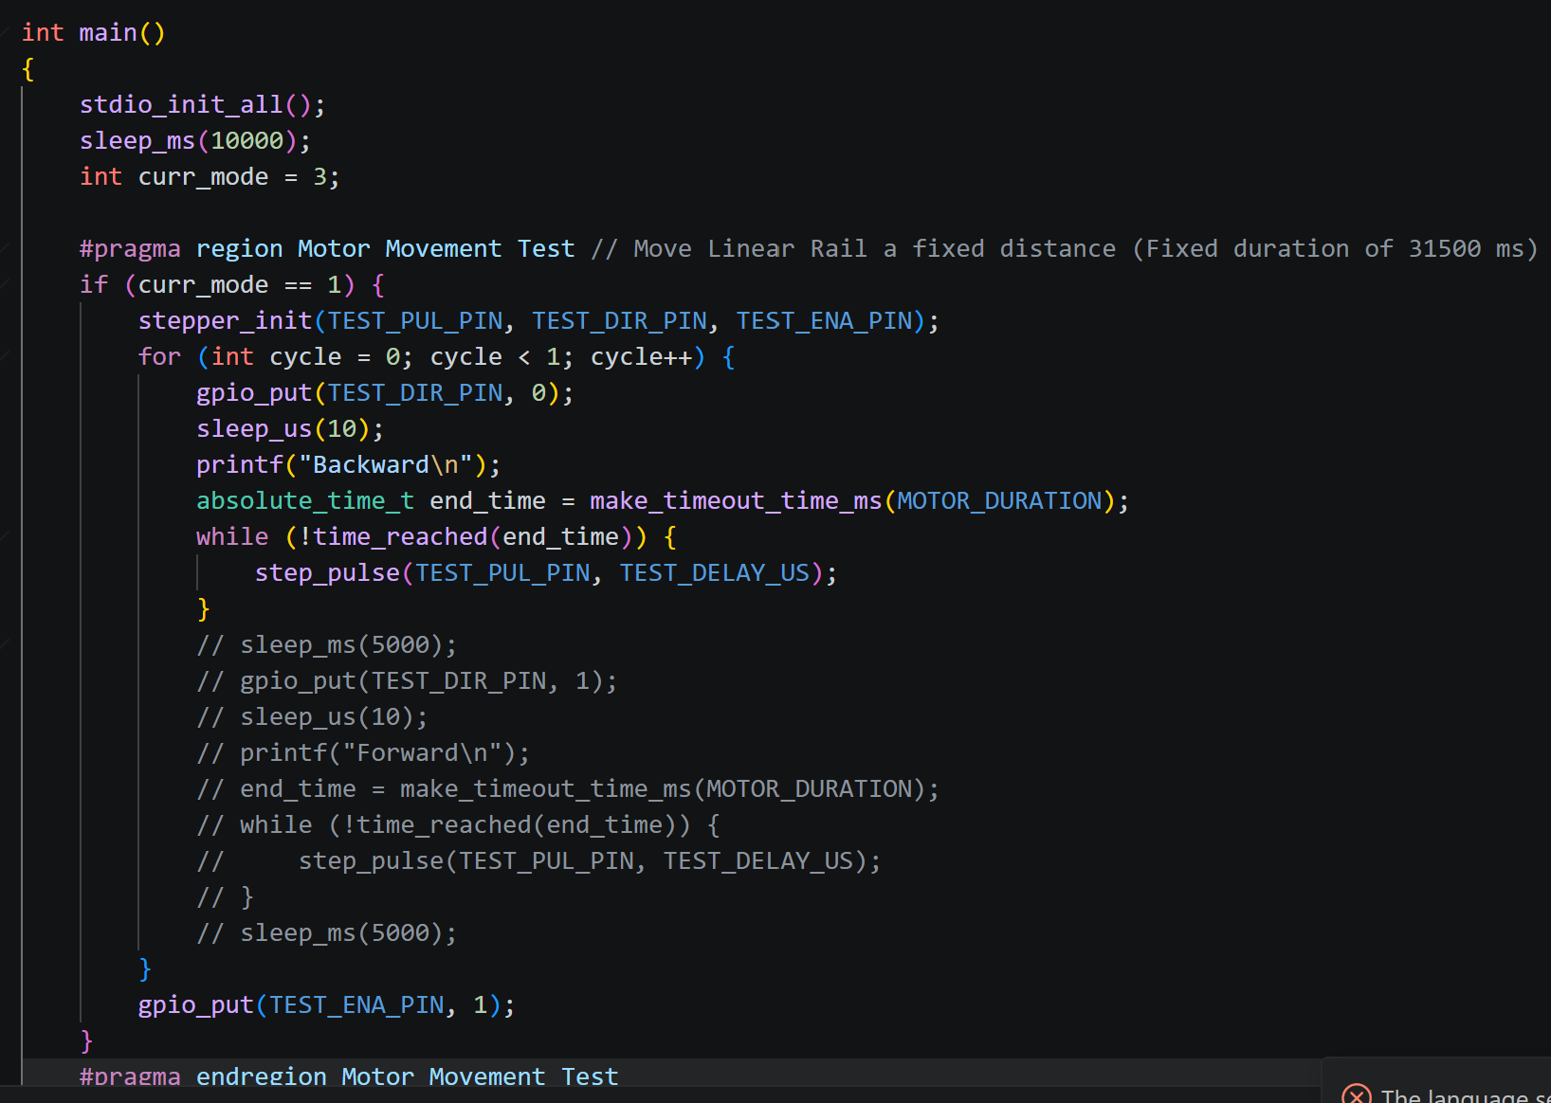

Appendix G.2 — ET3 Code
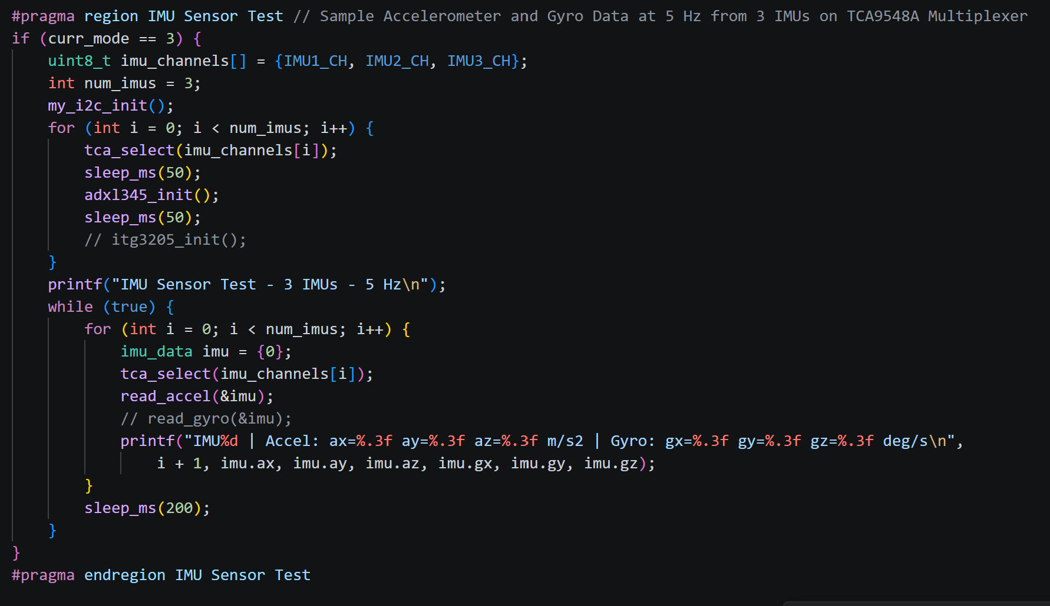

Appendix G.3 — ET4 Code
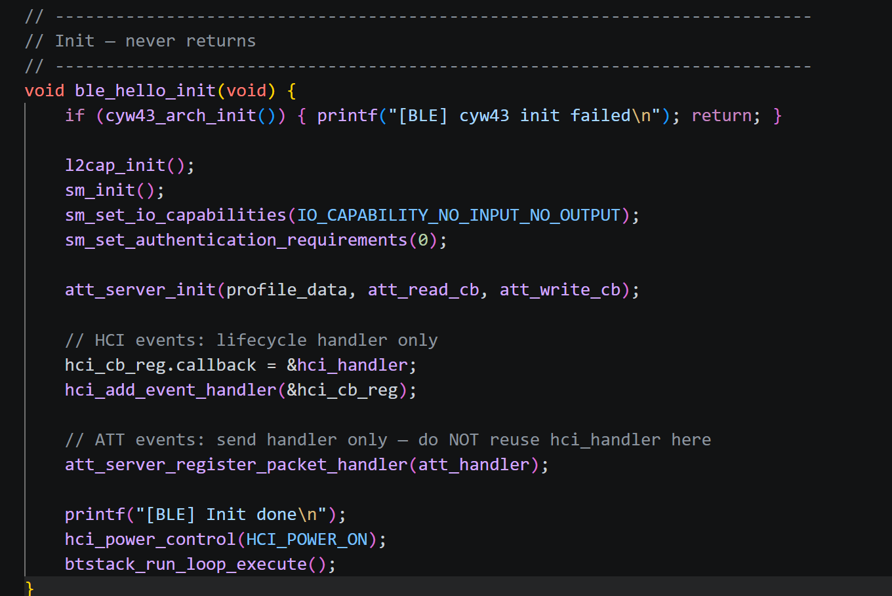

Appendix G.4 — ET7 Code
#include <stdio.h>
#include <string.h>
#include <stdlib.h>
#include <math.h>
#include "pico/stdlib.h"
#include "btstack_run_loop.h"
#include "hello_ble.h"
#include "pico/multicore.h"
#include "hardware/i2c.h"

// ── Tunable ───────────────────────────────────────────────────────────────────
#define MAX_EXERCISES 16
#define ACTIVE_REP_SEC 5 // seconds per active rep
#define MAX_DATA_ENTRIES 300 // session data log capacity
#define FLUSH_INTERVAL_MS 30 // ms between consecutive DATA| sends during flush
#define DIAG_PACKETS 25 // packets sent per DIAGTEST burst
#define DIAG_INTERVAL_MS 200 // 200 ms between packets = 5 Hz

// ── Motor (M1) — pins match KINETIX_test.c ───────────────────────────────────
#define MOTOR_PUL_PIN 0
#define MOTOR_DIR_PIN 1
#define MOTOR_ENA_PIN 2
#define MOTOR_DELAY_US 2500 // µs per half-pulse
#define MOTOR_DURATION 17000 // ms for one motor phase (FWD or BWD)

// ── HX711 load cell (H0 = plantar force) ─────────────────────────────────────
// Pin assignments verbatim from MOTORWORKS.c
#define H0_DATA 12
#define H0_CLOCK 13
// Calibration values from MOTORWORKS.c — re-run curr_mode==5 if hardware changes.
static int32_t hx711_offset[1] = { 1125691 };
static float hx711_scale[1] = { -800.7546f };

// ── I2C and IMU (ADXL345 via TCA9548A) ─────────────────────────────────────
// Pin assignments and channel mapping verbatim from KINETIX_test.c.
#define I2C_PORT i2c0
#define I2C_SDA_PIN 4
#define I2C_SCL_PIN 5
#define I2C_BAUDRATE 100000
#define IMU1_CH 5 // thigh
#define IMU2_CH 6 // shank
#define IMU3_CH 7 // back / trunk
#define ADXL345_ADDR 0x53
#define TCA9548A_ADDR 0x70

#define MOTOR_POLL_MS 50 // how often Core 0 checks for motor completion
#define ROLLING_N 8 // rolling average window (samples)

// ── Phase ─────────────────────────────────────────────────────────────────────
typedef enum {
PHASE_IDLE,
PHASE_WARMUP_RX,
PHASE_WARMUP_RUN,
PHASE_SESSION_RX,
PHASE_SESSION_RUN,
PHASE_FLUSH_RUN,
} phase_t;

static phase_t phase = PHASE_IDLE;

// ── Exercise plan ─────────────────────────────────────────────────────────────
typedef struct {
char code[20];
uint8_t sets;
uint8_t reps;
char mode; // 'A' active, 'P' passive
uint8_t param; // active: resistance level passive: seconds/rep
} exercise_t;

static uint8_t plan_expected = 0;
static uint8_t plan_received = 0;
static exercise_t plan[MAX_EXERCISES];

// ── Session data log ──────────────────────────────────────────────────────────
typedef struct {
char code[20];
uint32_t t_ms;
uint8_t rep; // 1-based
uint8_t set; // 1-based
float hip;
float knee;
float pf;
float tf;
float mf;
float lf;
} data_entry_t;

static data_entry_t data_log[MAX_DATA_ENTRIES];
static uint16_t data_count = 0;

// ── Session control ───────────────────────────────────────────────────────────
static volatile bool stopped = false;
static volatile bool paused = false;
static volatile bool timer_armed = false;

// ── Timer contexts ────────────────────────────────────────────────────────────
typedef struct {
btstack_timer_source_t timer;
uint8_t ex_idx;
uint8_t set_idx;
uint8_t rep_idx;
uint8_t tick; // elapsed seconds within current rep
uint32_t total_tick; // total ticks across session (for t_ms)
} run_ctx_t;

static run_ctx_t run_ctx;

typedef struct {
btstack_timer_source_t timer;
uint16_t idx; // index of next entry to send
} flush_ctx_t;

static flush_ctx_t flush_ctx;

// ── Diagnostic context ────────────────────────────────────────────────────────
typedef struct {
btstack_timer_source_t timer;
uint8_t seq; // current packet number (1–DIAG_PACKETS)
} diag_ctx_t;

static diag_ctx_t diag_ctx;
static bool diag_running = false;

// =============================================================================
// Forward declarations — required because motor_session_poll_cb and arm_timer
// reference functions defined later in the file.
// =============================================================================
static float get_hip_angle(void);
static float get_knee_angle(void);
static float get_plantar_force(void);
static float get_thigh_force(void);
static float get_medial_force(void);
static float get_lateral_force(void);
static void tick_callback(btstack_timer_source_t *ts);
// HX711 symbols and data used by core1_motor_entry (defined later in file)
static void hx711_init(uint8_t data_pin, uint8_t clock_pin);
static float hx711_read_force_nowait(uint8_t data_pin, uint8_t clock_pin, uint8_t unit);
// Plantar force cache: written by Core 1, read by Core 0 via get_plantar_force().
static volatile float pf_latest = 0.0f;

// =============================================================================
// Motor — Core 1 runs the blocking step loop; Core 0 (BLE) is never blocked.
// Core 0 sets motor_req_pending, Core 1 clears it and sets motor_is_done.
// A btstack poll timer on Core 0 detects motor_is_done and sends MOTOR_DONE.
// volatile is sufficient here: single writer / single reader per flag.
// =============================================================================

static volatile bool motor_req_pending = false;
static volatile bool motor_req_fwd = true;
static volatile uint32_t motor_req_ms = 3000;
static volatile bool motor_is_done = false;
static volatile bool motor_stop_req = false; // set by Core 0 to abort Core 1 mid-run

// ── stepper helpers (verbatim from KINETIX_test.c) ───────────────────────────
static void stepper_init_m(void) {
gpio_init(MOTOR_PUL_PIN); gpio_set_dir(MOTOR_PUL_PIN, GPIO_OUT);
gpio_init(MOTOR_DIR_PIN); gpio_set_dir(MOTOR_DIR_PIN, GPIO_OUT);
gpio_init(MOTOR_ENA_PIN); gpio_set_dir(MOTOR_ENA_PIN, GPIO_OUT);
gpio_put(MOTOR_ENA_PIN, 0); // enable driver (active LOW)
gpio_put(MOTOR_DIR_PIN, 1); // default forward
}

static void step_pulse_m(uint32_t pulse_width_us) {
gpio_put(MOTOR_PUL_PIN, 1); sleep_us(pulse_width_us);
gpio_put(MOTOR_PUL_PIN, 0); sleep_us(pulse_width_us);
}

// =============================================================================
// I2C helpers + IMU (ADXL345 via TCA9548A) — Core 1 only
// All I2C/GPIO operations live here; Core 0 reads only volatile caches.
// Functions are verbatim from KINETIX_test.c except for static linkage.
// =============================================================================

typedef struct { float ax, ay, az; } imu_accel_t;

static void my_i2c_init(void) {
i2c_init(I2C_PORT, I2C_BAUDRATE);
gpio_set_function(I2C_SDA_PIN, GPIO_FUNC_I2C);
gpio_set_function(I2C_SCL_PIN, GPIO_FUNC_I2C);
gpio_pull_up(I2C_SDA_PIN);
gpio_pull_up(I2C_SCL_PIN);
}

static int8_t i2c_write_bytes(uint8_t dev, uint8_t reg, uint8_t *data, size_t len) {
uint8_t buf[len + 1];
buf[0] = reg;
for (size_t i = 0; i < len; i++) buf[i + 1] = data[i];
return (int8_t)i2c_write_blocking(I2C_PORT, dev, buf, len + 1, false);
}

static int8_t i2c_read_bytes(uint8_t dev, uint8_t reg, uint8_t *data, size_t len) {
int ret = i2c_write_blocking(I2C_PORT, dev, &reg, 1, true);
if (ret < 0) return (int8_t)ret;
return (int8_t)i2c_read_blocking(I2C_PORT, dev, data, len, false);
}

static int tca_select(uint8_t ch) {
if (ch > 7) return -1;
uint8_t d = (uint8_t)(1u << ch);
return (i2c_write_blocking(I2C_PORT, TCA9548A_ADDR, &d, 1, false) == 1) ? 0 : -2;
}

static void adxl345_init(void) {
uint8_t d;
d = 0x00; i2c_write_bytes(ADXL345_ADDR, 0x2D, &d, 1); // standby
d = 0x0A; i2c_write_bytes(ADXL345_ADDR, 0x2C, &d, 1); // 100 Hz
d = 0x08; i2c_write_bytes(ADXL345_ADDR, 0x31, &d, 1); // full-res ±2g
d = 0x08; i2c_write_bytes(ADXL345_ADDR, 0x2D, &d, 1); // measure
}

static int read_accel(imu_accel_t *out) {
uint8_t raw[6];
if (i2c_read_bytes(ADXL345_ADDR, 0x32, raw, 6) < 0) {
out->ax = out->ay = out->az = 0.0f;
return -1;
}
out->ax = (float)(int16_t)((raw[1] << 8) | raw[0]) * 0.004f * 9.80665f;
out->ay = (float)(int16_t)((raw[3] << 8) | raw[2]) * 0.004f * 9.80665f;
out->az = (float)(int16_t)((raw[5] << 8) | raw[4]) * 0.004f * 9.80665f;
return 0;
}

// ── Angle caches — written by Core 1, read by Core 0 ─────────────────────────
//
// Angle computation (accelerometer only, quasi-static assumption):
// Each IMU has Z perpendicular to its limb segment. The long axis of the
// segment therefore lies in the IMU XY plane. The signed angle of the
// acceleration vector projected onto XY (relative to the +Y axis) gives the
// segment inclination from vertical in the sagittal plane:
// theta = atan2(ax, ay) [radians]
//
// Hip flexion = thigh angle (IMU1) − trunk angle (IMU3)
// Knee flexion = shank angle (IMU2) − thigh angle (IMU1)
//
// Both are positive for flexion. Adjust sign if sensors are mounted in the
// opposite orientation.
static volatile float hip_angle_latest = 0.0f; // degrees
static volatile float knee_angle_latest = 0.0f; // degrees

#define RAD_TO_DEG (180.0f / 3.14159265f)

// =============================================================================
// Rolling average — smooths sensor noise before values reach TICK messages.
// Window size ROLLING_N. All instances live on Core 1; Core 0 reads only
// the already-smoothed volatile caches.
// =============================================================================

typedef struct {
float buf[ROLLING_N];
uint8_t idx; // next write position
uint8_t count; // number of valid samples (0 → ROLLING_N)
float sum; // running sum for O(1) average
} rolling_avg_t;

// Push one sample, return the current rolling mean.
static float rolling_push(rolling_avg_t *r, float val) {
if (r->count < ROLLING_N) {
r->count++;
} else {
r->sum -= r->buf[r->idx]; // evict oldest sample
}
r->buf[r->idx] = val;
r->sum += val;
r->idx = (uint8_t)((r->idx + 1u) % ROLLING_N);
return r->sum / (float)r->count;
}

// One buffer per sensor channel — zero-initialised as static globals.
static rolling_avg_t hip_avg;
static rolling_avg_t knee_avg;
static rolling_avg_t pf_avg;

static void update_imu_angles(void) {
imu_accel_t a;
float th1 = 0.0f, th2 = 0.0f, th3 = 0.0f;

if (tca_select(IMU1_CH) == 0 && read_accel(&a) == 0)
th1 = atan2f(a.ax, a.ay) * RAD_TO_DEG;
if (tca_select(IMU2_CH) == 0 && read_accel(&a) == 0)
th2 = atan2f(a.ax, a.ay) * RAD_TO_DEG;
if (tca_select(IMU3_CH) == 0 && read_accel(&a) == 0)
th3 = atan2f(a.ax, a.ay) * RAD_TO_DEG;

hip_angle_latest = rolling_push(&hip_avg, th1 - th3);
knee_angle_latest = rolling_push(&knee_avg, th2 - th1);
}

// ── Core 1 entry point ────────────────────────────────────────────────────────
// Spins forever waiting for motor_req_pending. All GPIO and sleep_us calls
// happen here on Core 1, completely isolated from the BLE run loop on Core 0.
void core1_motor_entry(void) {
// ── Init all sensors on Core 1 ───────────────────────────────────────
hx711_init(H0_DATA, H0_CLOCK);
my_i2c_init();
const uint8_t imu_chs[3] = { IMU1_CH, IMU2_CH, IMU3_CH };
for (int i = 0; i < 3; i++) {
tca_select(imu_chs[i]);
sleep_ms(10);
adxl345_init();
}
printf("[CORE1] Sensors initialised\n");

uint32_t step_count = 0;

while (true) {
if (motor_req_pending) {
bool fwd = motor_req_fwd;
uint32_t ms = motor_req_ms;
motor_req_pending = false;
motor_stop_req = false;

stepper_init_m();
gpio_put(MOTOR_DIR_PIN, fwd ? 1 : 0);

absolute_time_t end_time = make_timeout_time_ms(ms);
while (!time_reached(end_time) && !motor_stop_req) {
step_pulse_m(MOTOR_DELAY_US);
step_count++;

// HX711: sample after every step when data pin is ready (~50 µs)
if (gpio_get(H0_DATA) == 0)
pf_latest = rolling_push(&pf_avg,
hx711_read_force_nowait(H0_DATA, H0_CLOCK, 0));

// IMU: sample every 100 steps (~500 ms) to stay well within
// the 1 Hz TICK rate without adding significant step overhead.
if (step_count % 100 == 0)
update_imu_angles();
}
motor_stop_req = false;
motor_is_done = true;

} else {
// Idle — sample both sensors continuously.
if (gpio_get(H0_DATA) == 0)
pf_latest = rolling_push(&pf_avg,
hx711_read_force_nowait(H0_DATA, H0_CLOCK, 0));
update_imu_angles();
}
}
}

// ── Motor test poll timer (used only by the manual Fwd/Bwd test buttons) ─────
typedef struct { btstack_timer_source_t timer; } motor_poll_ctx_t;
static motor_poll_ctx_t motor_poll_ctx;
static bool motor_poll_armed = false;

static void motor_poll_cb(btstack_timer_source_t *ts) {
if (motor_is_done) {
motor_is_done = false;
motor_poll_armed = false;
ble_enqueue("MOTOR_DONE");
hello_ble_send();
printf("[MOTOR] Done\n");
return; // disarm
}
btstack_run_loop_set_timer(ts, MOTOR_POLL_MS);
btstack_run_loop_add_timer(ts);
}

// =============================================================================
// Motor session state machine (Core 0 / btstack)
// Drives passive HKF / HKE exercises:
// FWD MOTOR_DURATION ms → BWD MOTOR_DURATION ms → rep done → repeat
// TICK is sent every ~1 s during the FWD phase (Ns = 1..MOTOR_DURATION/1000).
// Rep/set counters advance only after BWD completes.
// =============================================================================

// Returns true for any passive HKF or HKE exercise — these use the motor.
static bool is_motor_exercise(const exercise_t *ex) {
return ex->mode == 'P' &&
(strstr(ex->code, "HKF") != NULL ||
strstr(ex->code, "HKE") != NULL);
}

typedef struct {
btstack_timer_source_t timer;
bool fwd_phase; // true = FWD, false = BWD
uint32_t tick_sent; // last Ns value sent as a TICK
uint32_t total_ms; // cumulative ms for data log
uint32_t phase_duration_ms; // FWD (and BWD) duration
bool was_paused; // true after Core 1 was stopped for pause
uint32_t paused_remaining; // ms left in phase when paused
absolute_time_t phase_start_abs; // Core 0 hardware time when phase started
uint32_t phase_pre_elapsed_ms;// ms elapsed before current Core 1 run (resume)
} motor_session_ctx_t;

static motor_session_ctx_t ms_ctx;
static bool ms_running = false;

// Signal Core 1 to start a new FWD phase and reset per-phase counters.
// phase_ms: duration of both the FWD and BWD strokes for this exercise.
static void start_motor_rep_fwd(motor_session_ctx_t *ms, uint32_t phase_ms) {
ms->fwd_phase = true;
ms->tick_sent = 0;
ms->phase_duration_ms = phase_ms;
ms->was_paused = false;
ms->paused_remaining = 0;
ms->phase_pre_elapsed_ms = 0;
ms->phase_start_abs = get_absolute_time(); // real hardware time
motor_req_fwd = true;
motor_req_ms = phase_ms;
motor_is_done = false;
motor_stop_req = false;
motor_req_pending = true;
}

static void motor_session_poll_cb(btstack_timer_source_t *ts) {
motor_session_ctx_t *ms = (motor_session_ctx_t *)btstack_run_loop_get_timer_context(ts);
run_ctx_t *c = &run_ctx;

if (!ms_running) return;

// Phase guard — abort if session ended externally
if (phase != PHASE_WARMUP_RUN && phase != PHASE_SESSION_RUN) {
ms_running = false;
return;
}

if (stopped) {
motor_stop_req = true; // ask Core 1 to abort current run
ms_running = false;
timer_armed = false;
phase = PHASE_IDLE;
printf("[MOTOR SESSION] STOP\n");
return;
}

if (paused) {
if (!ms->was_paused) {
// First tick while paused — record real elapsed, stop Core 1
uint32_t real_so_far = ms->phase_pre_elapsed_ms +
(uint32_t)(absolute_time_diff_us(ms->phase_start_abs,
get_absolute_time()) / 1000);
ms->paused_remaining = (ms->phase_duration_ms > real_so_far)
? (ms->phase_duration_ms - real_so_far) : 0;
ms->was_paused = true;
motor_stop_req = true;
printf("[MOTOR SESSION] PAUSED — %lu ms remaining\n",
(unsigned long)ms->paused_remaining);
}
if (motor_is_done) motor_is_done = false;
btstack_run_loop_set_timer(ts, MOTOR_POLL_MS);
btstack_run_loop_add_timer(ts);
return;
}

// ── Resume after pause ────────────────────────────────────────────────
if (ms->was_paused) {
ms->was_paused = false;
// pre_elapsed = how far into the phase we already were
ms->phase_pre_elapsed_ms = ms->phase_duration_ms - ms->paused_remaining;
ms->phase_start_abs = get_absolute_time(); // reset clock for new run
printf("[MOTOR SESSION] RESUMED — %lu ms remaining\n",
(unsigned long)ms->paused_remaining);
if (ms->paused_remaining > 0) {
motor_req_fwd = ms->fwd_phase;
motor_req_ms = ms->paused_remaining;
motor_is_done = false;
motor_stop_req = false;
motor_req_pending = true;
} else {
motor_is_done = true;
}
}

// ── Real elapsed in current phase (hardware clock, not callback count) ──
uint32_t real_elapsed_ms = ms->phase_pre_elapsed_ms +
(uint32_t)(absolute_time_diff_us(ms->phase_start_abs,
get_absolute_time()) / 1000);
ms->total_ms += MOTOR_POLL_MS; // total_ms still approximate; data log only

// ── Send TICK every 1 s using real hardware time ──────────────────────
{
uint32_t Ns = real_elapsed_ms / 1000;
if (Ns > ms->tick_sent) {
ms->tick_sent = Ns;
const exercise_t *ex = &plan[c->ex_idx];
float hip = get_hip_angle();
float knee = get_knee_angle();
float pf = get_plantar_force();
float tf = get_thigh_force();
float mf = get_medial_force();
float lf = get_lateral_force();
// Log to session data buffer (FWD phase only)
if (ms->fwd_phase && phase == PHASE_SESSION_RUN && data_count < MAX_DATA_ENTRIES) {
data_entry_t *e = &data_log[data_count++];
strncpy(e->code, ex->code, sizeof(e->code) - 1);
e->code[sizeof(e->code)-1] = '\0';
e->t_ms = ms->total_ms;
e->rep = c->rep_idx + 1;
e->set = c->set_idx + 1;
e->hip = hip; e->knee = knee;
e->pf = pf; e->tf = tf;
e->mf = mf; e->lf = lf;
}
char msg[128];
if (ms->fwd_phase) {
// FWD: send elapsed seconds — UI uses this for progress ring
snprintf(msg, sizeof(msg),
"TICK|%s|%us|%u|%u|%.2f|%.2f|%.2f|%.2f|%.2f|%.2f",
ex->code, (unsigned)Ns,
(unsigned)(c->rep_idx + 1),
(unsigned)(c->set_idx + 1),
hip, knee, pf, tf, mf, lf);
} else {
// BWD: send RESETTING — UI shows "RESETTING" and collapses ring
snprintf(msg, sizeof(msg),
"TICK|%s|RESETTING|%u|%u|%.2f|%.2f|%.2f|%.2f|%.2f|%.2f",
ex->code,
(unsigned)(c->rep_idx + 1),
(unsigned)(c->set_idx + 1),
hip, knee, pf, tf, mf, lf);
}
ble_enqueue(msg);
hello_ble_send();
printf("%s\n", msg);
}
}

// ── Check for motor phase completion ──────────────────────────────────
if (!motor_is_done) {
btstack_run_loop_set_timer(ts, MOTOR_POLL_MS);
btstack_run_loop_add_timer(ts);
return;
}
motor_is_done = false;

if (ms->fwd_phase) {
// FWD done — start BWD (reset stroke)
printf("[MOTOR SESSION] FWD done → BWD\n");
ms->fwd_phase = false;
ms->tick_sent = 0;
ms->phase_pre_elapsed_ms = 0;
ms->phase_start_abs = get_absolute_time();
motor_req_fwd = false;
motor_req_ms = ms->phase_duration_ms;
motor_is_done = false;
motor_stop_req = false;
motor_req_pending = true;
btstack_run_loop_set_timer(ts, MOTOR_POLL_MS);
btstack_run_loop_add_timer(ts);
return;
}

// ── BWD done — rep complete ───────────────────────────────────────────
const exercise_t *ex = &plan[c->ex_idx];
printf("[MOTOR SESSION] Rep %u/%u Set %u/%u done\n",
(unsigned)(c->rep_idx + 1), (unsigned)ex->reps,
(unsigned)(c->set_idx + 1), (unsigned)ex->sets);

c->rep_idx++;
if (c->rep_idx < ex->reps) {
start_motor_rep_fwd(ms, ms->phase_duration_ms);
btstack_run_loop_set_timer(ts, MOTOR_POLL_MS);
btstack_run_loop_add_timer(ts);
return;
}

c->rep_idx = 0;
c->set_idx++;
if (c->set_idx < ex->sets) {
start_motor_rep_fwd(ms, ms->phase_duration_ms);
btstack_run_loop_set_timer(ts, MOTOR_POLL_MS);
btstack_run_loop_add_timer(ts);
return;
}

c->set_idx = 0;
c->ex_idx++;
if (c->ex_idx < plan_received) {
const exercise_t *next = &plan[c->ex_idx];
printf("[KINETIX] Next exercise: %s (%c)\n", next->code, next->mode);
if (is_motor_exercise(next)) {
uint32_t next_ms = (next->param > 0) ? (uint32_t)next->param * 1000u : MOTOR_DURATION;
start_motor_rep_fwd(ms, next_ms);
btstack_run_loop_set_timer(ts, MOTOR_POLL_MS);
btstack_run_loop_add_timer(ts);
} else {
// Switch back to the standard 1 s tick timer
ms_running = false;
c->tick = 0;
btstack_run_loop_set_timer_context(&run_ctx.timer, &run_ctx);
btstack_run_loop_set_timer_handler(&run_ctx.timer, tick_callback);
btstack_run_loop_set_timer(&run_ctx.timer, 1000);
btstack_run_loop_add_timer(&run_ctx.timer);
}
return;
}

// ── All exercises complete ────────────────────────────────────────────
ms_running = false;
timer_armed = false;
ble_enqueue("SESSION_DONE");
hello_ble_send();
const char *lbl = (phase == PHASE_WARMUP_RUN) ? "WARMUP" : "SESSION";
printf("[KINETIX] (%s) Complete — SESSION_DONE sent\n", lbl);
if (phase == PHASE_SESSION_RUN)
printf("[KINETIX] Data log: %u entries\n", (unsigned)data_count);
phase = PHASE_IDLE;
}

// =============================================================================
// HX711 load cell functions — verbatim from MOTORWORKS.c
// Called exclusively from Core 1. Core 0 reads only the pf_latest cache.
// hx711_wait_ready is never called from Core 0 — no CYW43 watchdog risk.
// =============================================================================

static void hx711_init(uint8_t data_pin, uint8_t clock_pin) {
gpio_init(data_pin);
gpio_set_dir(data_pin, GPIO_IN);
gpio_init(clock_pin);
gpio_set_dir(clock_pin, GPIO_OUT);
gpio_put(clock_pin, 0);
}

static void hx711_wait_ready(uint8_t data_pin) {
while (gpio_get(data_pin) == 1) {
tight_loop_contents();
}
}

static int32_t hx711_read_raw(uint8_t data_pin, uint8_t clock_pin) {
hx711_wait_ready(data_pin);
int32_t data = 0;
for (int i = 0; i < 24; i++) {
gpio_put(clock_pin, 1); sleep_us(1);
data = (data << 1) | gpio_get(data_pin);
gpio_put(clock_pin, 0); sleep_us(1);
}
gpio_put(clock_pin, 1); sleep_us(1);
gpio_put(clock_pin, 0); sleep_us(1);
if (data & 0x800000) data |= ~0xFFFFFF;
return data;
}

static float hx711_get_force(uint8_t data_pin, uint8_t clock_pin,
uint8_t unit, int samples) {
int64_t sum = 0;
for (int s = 0; s < samples; s++) sum += hx711_read_raw(data_pin, clock_pin);
int32_t avg = (int32_t)(sum / samples);
float force = (float)(avg - hx711_offset[unit]) / hx711_scale[unit];
if (force < 0.0f) force = 0.0f;
return force;
}

// =============================================================================
// Sensor placeholder functions
// ─────────────────────────────────────────────────────────────────────────────
// Each returns 0.0f until real hardware reads are implemented.
// Replace the body of each function with your IMU / HX711 read call.
// The rest of the firmware does not need to change.
// =============================================================================

static float get_hip_angle(void) { return (float)hip_angle_latest; }
static float get_knee_angle(void) { return (float)knee_angle_latest; }

// Read 24 bits WITHOUT a blocking wait (data pin must already be LOW).
// Called only from Core 1 — gpio_put / sleep_us are safe here.
static float hx711_read_force_nowait(uint8_t data_pin, uint8_t clock_pin,
uint8_t unit) {
int32_t raw = 0;
for (int i = 0; i < 24; i++) {
gpio_put(clock_pin, 1); sleep_us(1);
raw = (raw << 1) | gpio_get(data_pin);
gpio_put(clock_pin, 0); sleep_us(1);
}
// 25th pulse sets Channel A gain 128 for next conversion
gpio_put(clock_pin, 1); sleep_us(1);
gpio_put(clock_pin, 0); sleep_us(1);
if (raw & 0x800000) raw |= ~0xFFFFFF;
float force = (float)(raw - hx711_offset[unit]) / hx711_scale[unit];
return (force < 0.0f) ? 0.0f : force;
}

// Core 0 NEVER calls gpio_put/get for HX711 — returns the Core 1 cache only.
static float get_plantar_force(void) { return (float)pf_latest; }
static float get_thigh_force(void) { return 0.0f; } // TODO: HX711 thigh sensor
static float get_medial_force(void) { return 0.0f; } // TODO: HX711 medial sensor
static float get_lateral_force(void) { return 0.0f; } // TODO: HX711 lateral sensor

// =============================================================================
// Report flush timer — sends one DATA| line every FLUSH_INTERVAL_MS
// =============================================================================

static void flush_timer_callback(btstack_timer_source_t *ts) {
flush_ctx_t *fc = (flush_ctx_t *)btstack_run_loop_get_timer_context(ts);

if (fc->idx >= data_count) {
// All entries sent
ble_enqueue("REPORT_DONE");
hello_ble_send();
printf("[KINETIX] Report flush complete — %u entries sent\n",
(unsigned)data_count);
data_count = 0; // clear log for next session
timer_armed = false;
phase = PHASE_IDLE;
return;
}

const data_entry_t *e = &data_log[fc->idx++];
char msg[128];
snprintf(msg, sizeof(msg),
"DATA|%s|%lu|%u|%u|%.2f|%.2f|%.2f|%.2f|%.2f|%.2f",
e->code,
(unsigned long)e->t_ms,
(unsigned)e->rep,
(unsigned)e->set,
e->hip, e->knee,
e->pf, e->tf,
e->mf, e->lf);
ble_enqueue(msg);
hello_ble_send();

btstack_run_loop_set_timer(ts, FLUSH_INTERVAL_MS);
btstack_run_loop_add_timer(ts);
}

static void start_flush(void) {
if (data_count == 0) {
ble_enqueue("REPORT_DONE");
hello_ble_send();
printf("[KINETIX] No data to flush\n");
return;
}
printf("[KINETIX] Starting flush — %u entries at %d ms/entry\n",
(unsigned)data_count, FLUSH_INTERVAL_MS);
phase = PHASE_FLUSH_RUN;
timer_armed = true;
flush_ctx.idx = 0;
btstack_run_loop_set_timer_context(&flush_ctx.timer, &flush_ctx);
btstack_run_loop_set_timer_handler(&flush_ctx.timer, flush_timer_callback);
btstack_run_loop_set_timer(&flush_ctx.timer, FLUSH_INTERVAL_MS);
btstack_run_loop_add_timer(&flush_ctx.timer);
}

// =============================================================================
// Tick timer — fires every 1 000 ms during WARMUP_RUN or SESSION_RUN
// =============================================================================

static void tick_callback(btstack_timer_source_t *ts) {
run_ctx_t *c = (run_ctx_t *)btstack_run_loop_get_timer_context(ts);

// ── Phase guard ────────────────────────────────────────────────────────────
// Reject spurious callbacks that arrive after the phase has already moved
// to IDLE (e.g. natural session completion, mid-session REPORT, or STOP).
// Without this guard a late-firing callback reads plan[ex_idx] where
// ex_idx == plan_received — one past the end of the array — which is
// undefined behaviour and causes the last exercise to appear to repeat.
if (phase != PHASE_WARMUP_RUN && phase != PHASE_SESSION_RUN) {
timer_armed = false;
return;
}

if (stopped) {
printf("[KINETIX] Aborted by STOP\n");
timer_armed = false;
phase = PHASE_IDLE;
return;
}

if (paused) {
btstack_run_loop_set_timer(ts, 1000);
btstack_run_loop_add_timer(ts);
return;
}

c->tick++;
c->total_tick++;

const exercise_t *ex = &plan[c->ex_idx];

// ── Read sensors once per tick ─────────────────────────────────────────
float hip = get_hip_angle();
float knee = get_knee_angle();
float pf = get_plantar_force();
float tf = get_thigh_force();
float mf = get_medial_force();
float lf = get_lateral_force();

// ── Log to data buffer during SESSION_RUN only ─────────────────────────
if (phase == PHASE_SESSION_RUN && data_count < MAX_DATA_ENTRIES) {
data_entry_t *entry = &data_log[data_count++];
strncpy(entry->code, ex->code, sizeof(entry->code) - 1);
entry->code[sizeof(entry->code) - 1] = '\0';
entry->t_ms = (uint32_t)(c->total_tick * 1000u);
entry->rep = c->rep_idx + 1;
entry->set = c->set_idx + 1;
entry->hip = hip;
entry->knee = knee;
entry->pf = pf;
entry->tf = tf;
entry->mf = mf;
entry->lf = lf;
}

// ── Build progress field ───────────────────────────────────────────────
char progress[12];
bool rep_done;

if (ex->mode == 'A') {
uint8_t pct = (uint8_t)((c->tick * 100u) / ACTIVE_REP_SEC);
if (pct > 100) pct = 100;
snprintf(progress, sizeof(progress), "%u", (unsigned)pct);
rep_done = (c->tick >= ACTIVE_REP_SEC);
} else {
snprintf(progress, sizeof(progress), "%us", (unsigned)c->tick);
rep_done = (c->tick >= ex->param);
}

// ── Emit TICK|CODE|progress|rep|set|hip|knee|pf|tf|mf|lf ──────────────
char msg[128];
snprintf(msg, sizeof(msg),
"TICK|%s|%s|%u|%u|%.2f|%.2f|%.2f|%.2f|%.2f|%.2f",
ex->code,
progress,
(unsigned)(c->rep_idx + 1),
(unsigned)(c->set_idx + 1),
hip, knee, pf, tf, mf, lf);
ble_enqueue(msg);
hello_ble_send();
printf("%s\n", msg);

// ── Advance counters on rep completion ─────────────────────────────────
if (!rep_done) {
btstack_run_loop_set_timer(ts, 1000);
btstack_run_loop_add_timer(ts);
return;
}

c->tick = 0;
c->rep_idx++;

if (c->rep_idx < ex->reps) {
btstack_run_loop_set_timer(ts, 1000);
btstack_run_loop_add_timer(ts);
return;
}

c->rep_idx = 0;
c->set_idx++;

if (c->set_idx < ex->sets) {
btstack_run_loop_set_timer(ts, 1000);
btstack_run_loop_add_timer(ts);
return;
}

c->set_idx = 0;
c->ex_idx++;

if (c->ex_idx < plan_received) {
const char *label = (phase == PHASE_WARMUP_RUN) ? "WARMUP" : "SESSION";
printf("[KINETIX] (%s) Exercise %u/%u — %s (%c)\n",
label,
(unsigned)(c->ex_idx + 1), (unsigned)plan_received,
plan[c->ex_idx].code, plan[c->ex_idx].mode);
btstack_run_loop_set_timer(ts, 1000);
btstack_run_loop_add_timer(ts);
return;
}

// ── Phase complete ─────────────────────────────────────────────────────
ble_enqueue("SESSION_DONE");
hello_ble_send();
const char *label = (phase == PHASE_WARMUP_RUN) ? "WARMUP" : "SESSION";
printf("[KINETIX] (%s) Complete — SESSION_DONE sent\n", label);
if (phase == PHASE_SESSION_RUN)
printf("[KINETIX] Data log: %u entries — send REPORT to flush\n",
(unsigned)data_count);
timer_armed = false;
phase = PHASE_IDLE;
// Explicit return — belt-and-suspenders: ensures the timer is never
// re-armed by any code that might be added below this point in future.
return;
}

// ── Arm the tick timer ────────────────────────────────────────────────────────
static void arm_timer(void) {
run_ctx.ex_idx = 0;
run_ctx.set_idx = 0;
run_ctx.rep_idx = 0;
run_ctx.tick = 0;
run_ctx.total_tick = 0;

const char *label = (phase == PHASE_WARMUP_RUN) ? "WARMUP" : "SESSION";
printf("[KINETIX] (%s) Starting — %u exercise(s)\n", label,
(unsigned)plan_received);
for (uint8_t i = 0; i < plan_received; i++)
printf(" [%u] code=%-20s sets=%u reps=%u mode=%c param=%u\n",
(unsigned)(i + 1), plan[i].code,
(unsigned)plan[i].sets, (unsigned)plan[i].reps,
plan[i].mode, (unsigned)plan[i].param);

if (plan_received > 0 && is_motor_exercise(&plan[0])) {
// Motor-driven session: use the 50 ms poll callback
ms_ctx.fwd_phase = false; // start_motor_rep_fwd sets this
ms_ctx.tick_sent = 0;
ms_ctx.total_ms = 0;
ms_ctx.phase_pre_elapsed_ms = 0;
ms_ctx.phase_start_abs = get_absolute_time();
ms_running = true;
uint32_t phase_ms = (plan[0].param > 0)
? (uint32_t)plan[0].param * 1000u
: MOTOR_DURATION; // fallback: 17 s
start_motor_rep_fwd(&ms_ctx, phase_ms);
btstack_run_loop_set_timer_context(&ms_ctx.timer, &ms_ctx);
btstack_run_loop_set_timer_handler(&ms_ctx.timer, motor_session_poll_cb);
btstack_run_loop_set_timer(&ms_ctx.timer, MOTOR_POLL_MS);
btstack_run_loop_add_timer(&ms_ctx.timer);
} else {
// Standard 1 s tick-based session
btstack_run_loop_set_timer_context(&run_ctx.timer, &run_ctx);
btstack_run_loop_set_timer_handler(&run_ctx.timer, tick_callback);
btstack_run_loop_set_timer(&run_ctx.timer, 1000);
btstack_run_loop_add_timer(&run_ctx.timer);
}
timer_armed = true;
}

// ── Cancel whichever timer is currently armed ─────────────────────────────────
static void cancel_timer(void) {
if (!timer_armed) return;
if (phase == PHASE_FLUSH_RUN) {
btstack_run_loop_remove_timer(&flush_ctx.timer);
} else if (ms_running) {
btstack_run_loop_remove_timer(&ms_ctx.timer);
ms_running = false;
motor_stop_req = true; // abort any in-progress motor run on Core 1
} else {
btstack_run_loop_remove_timer(&run_ctx.timer);
}
timer_armed = false;
printf("[KINETIX] Timer cancelled\n");
}

// ── Parse one EX| line into plan[plan_received] ───────────────────────────────
static int parse_ex(const char *line) {
char buf[80];
strncpy(buf, line, sizeof(buf) - 1);
buf[sizeof(buf) - 1] = '\0';

char *tok = strtok(buf, "|"); // "EX"
tok = strtok(NULL, "|"); if (!tok) return 0; // code
strncpy(plan[plan_received].code, tok,
sizeof(plan[plan_received].code) - 1);
plan[plan_received].code[sizeof(plan[plan_received].code) - 1] = '\0';

tok = strtok(NULL, "|"); if (!tok) return 0; // sets
plan[plan_received].sets = (uint8_t)atoi(tok);

tok = strtok(NULL, "|"); if (!tok) return 0; // reps
plan[plan_received].reps = (uint8_t)atoi(tok);

tok = strtok(NULL, "|"); if (!tok) return 0; // mode
plan[plan_received].mode = tok[0];

tok = strtok(NULL, "|"); if (!tok) return 0; // param
plan[plan_received].param = (uint8_t)atoi(tok);
if (plan[plan_received].mode == 'P' && plan[plan_received].param == 0)
plan[plan_received].param = 5;

return 1;
}

// =============================================================================
// Diagnostic burst timer — fires every DIAG_INTERVAL_MS on the btstack run loop
// Sends DIAG_PACKETS packets at 5 Hz, then DIAG_DONE, then disarms itself.
// =============================================================================

static void diag_timer_callback(btstack_timer_source_t *ts) {
diag_ctx_t *dc = (diag_ctx_t *)btstack_run_loop_get_timer_context(ts);
dc->seq++;

char msg[24];
snprintf(msg, sizeof(msg), "DIAG|%u", (unsigned)dc->seq);
ble_enqueue(msg);
hello_ble_send();
printf("[DIAG] %s\n", msg);

if (dc->seq >= DIAG_PACKETS) {
ble_enqueue("DIAG_DONE");
hello_ble_send();
printf("[DIAG] Burst complete — %u packets sent\n", (unsigned)DIAG_PACKETS);
diag_running = false;
return; // not re-armed — burst finished
}

btstack_run_loop_set_timer(ts, DIAG_INTERVAL_MS);
btstack_run_loop_add_timer(ts);
}

// =============================================================================
// BLE receive callback
// =============================================================================
void on_ble_receive(const char *line) {
printf("[RX] %s\n", line);

// ── PING — keepalive, discard silently ────────────────────────────────────
if (strcmp(line, "PING") == 0) return;

// ── LATPING|<seq> — immediate round-trip latency probe ────────────────────
// Accepted in any phase so it never disturbs an ongoing session.
if (strncmp(line, "LATPING|", 8) == 0) {
char pong[32];
snprintf(pong, sizeof(pong), "LATPONG|%s", line + 8);
ble_enqueue(pong);
hello_ble_send();
return;
}

// ── DIAGTEST — trigger a 5 Hz burst of DIAG_PACKETS packets ───────────────
// Only accepted in PHASE_IDLE to prevent interference with sessions.
if (strcmp(line, "DIAGTEST") == 0) {
if (phase != PHASE_IDLE || diag_running) {
ble_enqueue("DIAG_BUSY");
hello_ble_send();
printf("[DIAG] DIAGTEST rejected — phase=%d running=%d\n",
(int)phase, (int)diag_running);
return;
}
diag_running = true;
diag_ctx.seq = 0;
btstack_run_loop_set_timer_context(&diag_ctx.timer, &diag_ctx);
btstack_run_loop_set_timer_handler(&diag_ctx.timer, diag_timer_callback);
btstack_run_loop_set_timer(&diag_ctx.timer, DIAG_INTERVAL_MS);
btstack_run_loop_add_timer(&diag_ctx.timer);
printf("[DIAG] DIAGTEST started — %u packets at %d ms intervals\n",
(unsigned)DIAG_PACKETS, DIAG_INTERVAL_MS);
return;
}

// ── STOP ─────────────────────────────────────────────────────────────────
// Preserves data_count so REPORT still works after a manual end-session.
if (strcmp(line, "STOP") == 0) {
cancel_timer();
stopped = true;
paused = false;
phase = PHASE_IDLE;
ble_enqueue("STOPPED");
hello_ble_send();
printf("[KINETIX] STOP — data log holds %u entries\n",
(unsigned)data_count);
return;
}

// ── PAUSE ─────────────────────────────────────────────────────────────────
if (strcmp(line, "PAUSE") == 0) {
paused = true;
ble_enqueue("PAUSED");
hello_ble_send();
return;
}

// ── RESUME ────────────────────────────────────────────────────────────────
if (strcmp(line, "RESUME") == 0) {
paused = false;
ble_enqueue("RESUMED");
hello_ble_send();
return;
}

// ── REPORT ────────────────────────────────────────────────────────────────
// Accepted in two situations:
// (a) PHASE_IDLE — session completed naturally or was already stopped.
// (b) PHASE_SESSION_RUN — clinician pressed "End Session" early.
// The tick timer is cancelled immediately, the data log is preserved,
// and the flush begins. This is the fix for the REPORT_BUSY symptom
// that occurs when the dashboard requests data before STOP is received.
if (strcmp(line, "REPORT") == 0) {
if (phase == PHASE_SESSION_RUN) {
// Mid-session early exit: stop the tick timer, keep data intact.
cancel_timer();
stopped = true;
paused = false;
phase = PHASE_IDLE;
printf("[KINETIX] REPORT mid-session — cancelled tick, flushing %u entries\n",
(unsigned)data_count);
start_flush();
return;
}
if (phase != PHASE_IDLE) {
// Any other running phase (warmup, flush already in progress, etc.)
ble_enqueue("REPORT_BUSY");
hello_ble_send();
printf("[KINETIX] REPORT rejected — phase=%d\n", (int)phase);
return;
}
start_flush();
return;
}

// ── WARMUP|N ──────────────────────────────────────────────────────────────
if (strncmp(line, "WARMUP|", 7) == 0) {
cancel_timer();
plan_expected = (uint8_t)atoi(line + 7);
if (plan_expected > MAX_EXERCISES) plan_expected = MAX_EXERCISES;
plan_received = 0;
stopped = false;
paused = false;
phase = PHASE_WARMUP_RX;
printf("[KINETIX] WARMUP — expecting %u exercise(s)\n",
(unsigned)plan_expected);
return;
}

// ── START|N ───────────────────────────────────────────────────────────────
if (strncmp(line, "START|", 6) == 0) {
cancel_timer();
data_count = 0; // clear log for new session
plan_expected = (uint8_t)atoi(line + 6);
if (plan_expected > MAX_EXERCISES) plan_expected = MAX_EXERCISES;
plan_received = 0;
stopped = false;
paused = false;
phase = PHASE_SESSION_RX;
printf("[KINETIX] SESSION — expecting %u exercise(s)\n",
(unsigned)plan_expected);
return;
}

// ── EX| ───────────────────────────────────────────────────────────────────
if (strncmp(line, "EX|", 3) == 0 &&
(phase == PHASE_WARMUP_RX || phase == PHASE_SESSION_RX) &&
plan_expected > 0)
{
if (plan_received >= plan_expected) return;

if (!parse_ex(line)) {
printf("[KINETIX] EX parse error: %s\n", line);
return;
}

printf("[KINETIX] EX[%u] code=%-20s sets=%u reps=%u mode=%c param=%u\n",
(unsigned)plan_received,
plan[plan_received].code,
(unsigned)plan[plan_received].sets,
(unsigned)plan[plan_received].reps,
plan[plan_received].mode,
(unsigned)plan[plan_received].param);

plan_received++;

if (plan_received >= plan_expected) {
if (phase == PHASE_WARMUP_RX) {
phase = PHASE_WARMUP_RUN;
ble_enqueue("THE DEVICE HAS RECEIVED THE WARMUP PLAN");
} else {
phase = PHASE_SESSION_RUN;
ble_enqueue("THE DEVICE HAS RECEIVED THE TREATMENT PLAN");
}
hello_ble_send();
printf("[KINETIX] Plan complete — arming timer\n");
arm_timer();
}
return;
}

// ── MOTOR_FWD|<ms> / MOTOR_BWD|<ms> ─────────────────────────────────────
// Signals Core 1 to run the motor; Core 0 (BLE) never blocks.
if (strncmp(line, "MOTOR_FWD|", 10) == 0 || strncmp(line, "MOTOR_BWD|", 10) == 0) {
if (phase != PHASE_IDLE || motor_req_pending) {
ble_enqueue("MOTOR_BUSY");
hello_ble_send();
return;
}
bool fwd = (strncmp(line, "MOTOR_FWD|", 10) == 0);
uint32_t ms = (uint32_t)atoi(line + 10);
if (ms == 0 || ms > 10000) ms = 3000;

motor_req_fwd = fwd;
motor_req_ms = ms;
motor_is_done = false;
motor_req_pending = true; // Core 1 picks this up

if (!motor_poll_armed) {
motor_poll_armed = true;
btstack_run_loop_set_timer_context(&motor_poll_ctx.timer, &motor_poll_ctx);
btstack_run_loop_set_timer_handler(&motor_poll_ctx.timer, motor_poll_cb);
btstack_run_loop_set_timer(&motor_poll_ctx.timer, MOTOR_POLL_MS);
btstack_run_loop_add_timer(&motor_poll_ctx.timer);
}
printf("[MOTOR] %s %lu ms — Core 1 started\n", fwd ? "FWD" : "BWD", (unsigned long)ms);
return;
}

// ── SREAD — one-shot sensor snapshot for diagnostics (PHASE_IDLE only) ───
// Phone sends SREAD at ~2 Hz; Pico replies SENSOR|hip|knee|pf.
// Only accepted when idle so it cannot interfere with a running session.
if (strcmp(line, "SREAD") == 0) {
if (phase != PHASE_IDLE) {
ble_enqueue("SENSOR_BUSY");
hello_ble_send();
return;
}
char smsg[64];
snprintf(smsg, sizeof(smsg), "SENSOR|%.2f|%.2f|%.2f",
(float)hip_angle_latest,
(float)knee_angle_latest,
(float)pf_latest);
ble_enqueue(smsg);
hello_ble_send();
return;
}

printf("[RX] Unrecognised (phase=%d): %s\n", (int)phase, line);
}

// =============================================================================
// main
// =============================================================================
int main(void) {
stdio_init_all();
multicore_launch_core1(core1_motor_entry); // Core 1 handles all motor GPIO
sleep_ms(5000);
printf("KINETIX BLE — waiting for connection...\n");
printf(" WARMUP|N → warmup phase\n");
printf(" START|N → treatment session\n");
printf(" REPORT → flush logged data\n");
ble_hello_init();
}

